A CASE OF CORNS ON SOLE OF FOOT
Dr Manpreet Kaur
BHMS, MD(Hom.), PhD(Hom.)
Department of Pathology
JR Kissan Homoeopathic Medical College
and Hospital
INTRODUCTION
A 19 year old boy presented to me on 19.01.2015

PRESENTING COMPLAINTS
Corns on the soles of both feet since 6 months
There was pain on the corns while walking and jogging.
The corns were painful to touch also.
He was using corn tips over the corns.
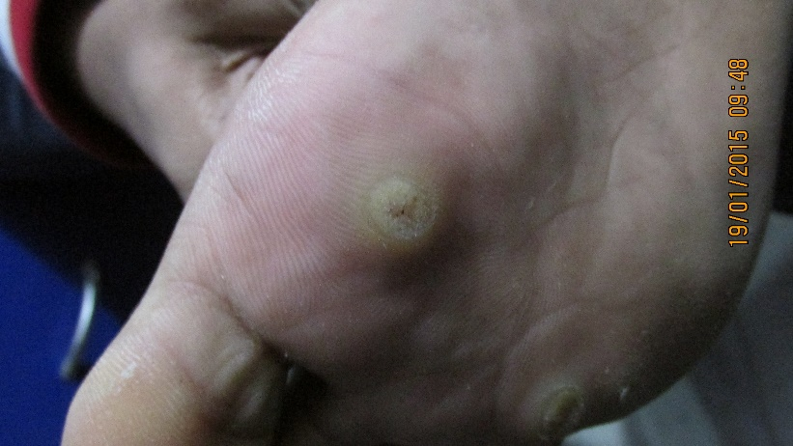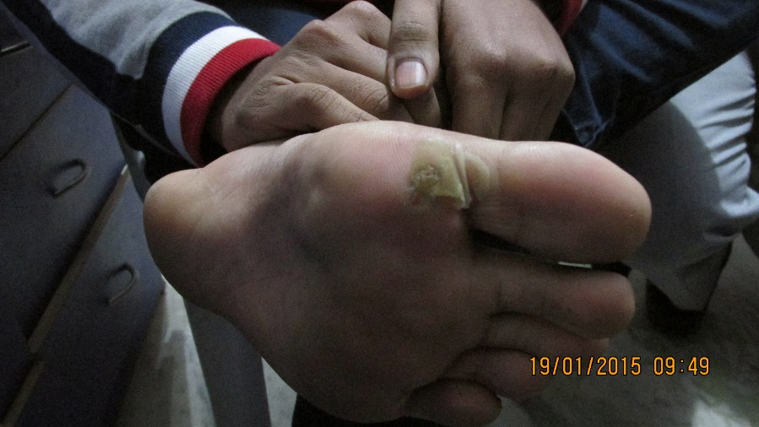

HISTORY OF PRESENTING COMPLAINTS
The patient was apparently well 6 months back when he started developing small eruptions on the soles of both feet to which he did not give much importance. Then he went to Dubai to study engineering at BITS Pilani- Dubai. There is observed that the size of these eruptions was increasing, which took the shape of corns. He used corn tips which led to disappearance of a corn, but another corn erupted over the skin nearby to that corn.
The corns are painful, pain is felt in them while walking or jogging. Applying corn tips leads to disappearance of corn at one place but later on leading to an appearance of another corn at a changed location on the sole of the foot itself.

PAST HISTORY- nothing much significant found
FAMILY HISTORY- Maternal Grandmother – had Ca cervix
PHYSICAL GENERALS
Appetite: good
Thirst: 3-4 liters/ day (increased)
Desire: sweet, spicy, farinaceous food, eggs
Aversion: bland food
Urine: NAD
Stool: NAD
Sleep: deep sleep
Dreams: nothing significant found
Perspiration: offensive; offensive foot sweat
Thermal reaction: Hot
Tongue: trembling; anteriorly red; papillae raised

MENTAL GENERALS
Wants the BEST of everything
Fears (lots of fears) in childhood
Stores all the old things
During anger, throws away the things

PRESCRIPTION
19.01.2015
R_{x}
Calcarea carbonica 0/1/ BD

Advise:
- Don’t apply any external applications over the corns
- Don’t apply corn tips
- Don’t pluck corns or disfigure them with hands

FOLLOW UP
- 30.01.2015
- Marked improvement
- Tongue: raised papillae; fiery red anteriorly (with tip); trembling; coated posteriorly
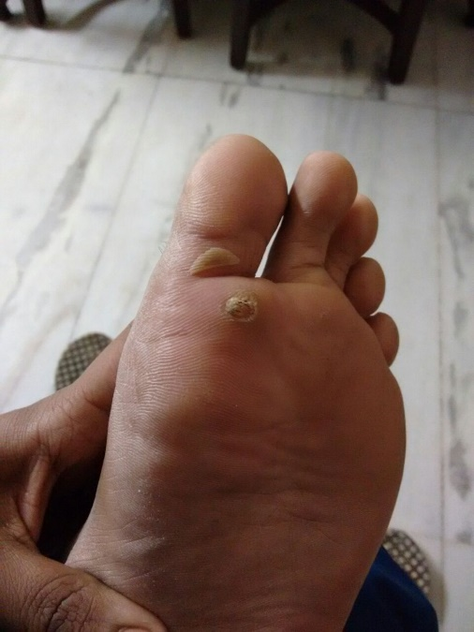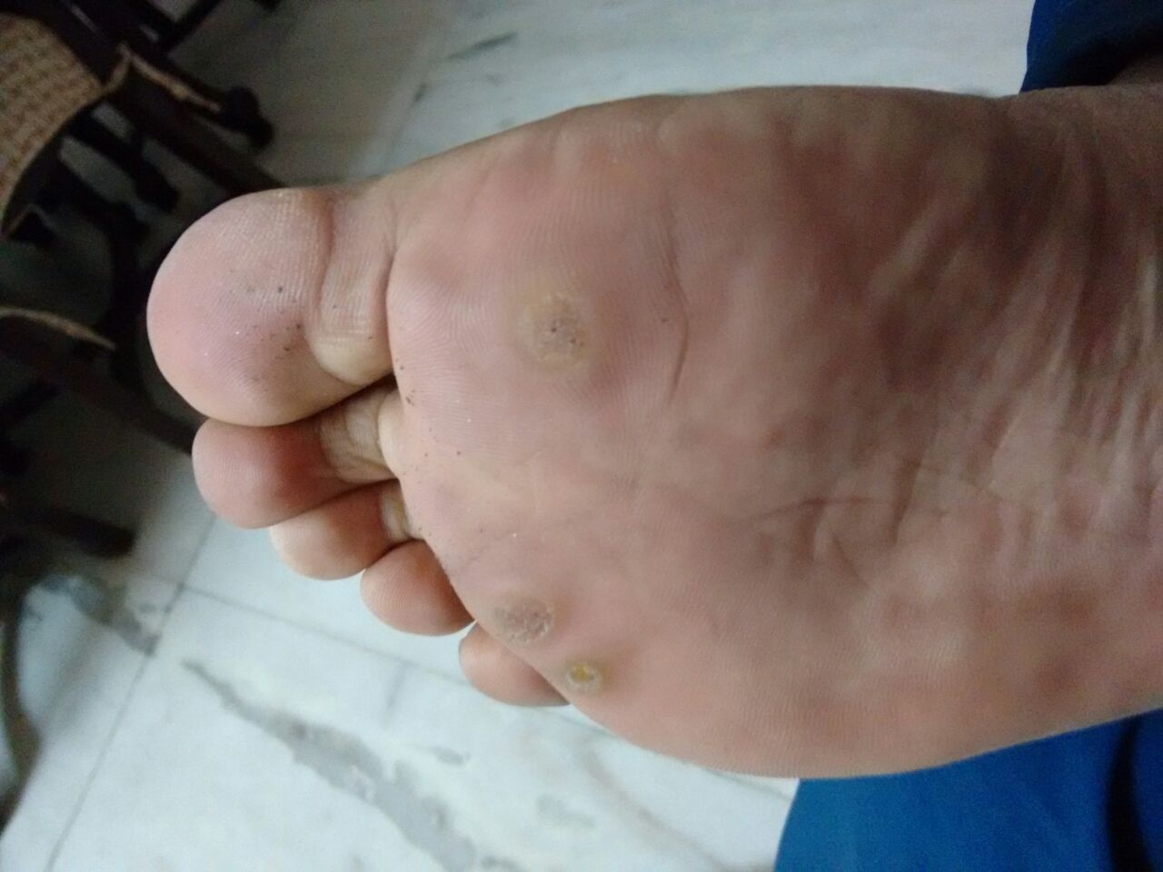
PICS TAKEN ON 30.1.2015
Prescription
R_{x}
Calcarea carbonica 0/2, 0/3, 0/4, 0/5, 0/6, 0/7, 0/8, 0/9/ BD (2 months)
Patient went to Dubai after taking the medicines from me for 2 months.

09.03.2015
Pics sent by his father

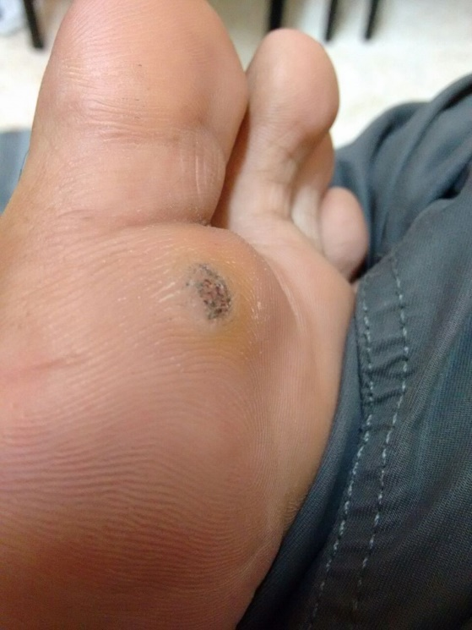
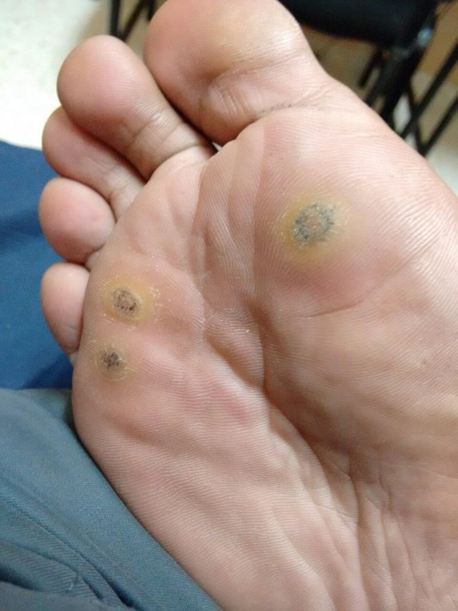

After that, this patient was cured of these warts- as reported to me by his family members.

