DR. SHARON ARTHUR
STUDYING P.G. In J.S.P.S GOVT. COLLEGE
HYDERABAD

VITILIGO : A CASE REPORT

Introduction:
Vitiligo is a disorder of skin pigmentation. It effects approximately 1% of world population. It occurs equally between the sexes with no racial predilection. The majority of cases are acquired and arise between second and third decades of life. Acquired Vitiligo has an unpredictable clinical course. Congenital Vitiligo is rare and few reported cases. The Psychosocial burden can have a profound impact on quality of life. The unknown course of Vitiligo can exacerbate the feeling of distress and embarrassment.(1)

Case Summary:
This is a case of a male, 33 years old with a symmetrical hypopigmented patch on the face since 2 years. After individualizing the case, homeopathic medicine Sep 30 was prescribed and the whole patch was resolved within a period of 1 month.

Keywords: Sepia, Case report, Homeopathy, Vitiligo.
Introduction: Vitiligo is a common pigmentary disorder seen in our country. It is an acquired idiopathic depigmentary condition. It is characterized by completely depigmented milky white macules of varying sizes and shapes. Besides loss of colour, there is no other structural changes. It causes cosmetic disfigurement leading to psychological trauma to the patient. The untiring efforts of the scientists over a period of many years have failed to lift up the curtain of ignorance till today and Vitiligo is still an enigma. Various theories of origin, genetic, toxic, neurogenic and auto immune have been proposed by different workers, yet none is definite. (1) In 2011, an international consensus classified Vitiligo into two major forms: Non-Segmental Vitiligo (NSV) and Segmental Vitiligo (SV). Research into the pathogenesis of Vitiligo suggests that oxidative stress may be the initial event in the destruction of Melanocytes. (2)

Case Presentation:
A 33-year-old male came on 16 December 2019 to the Free clinic conducted in community hall in Swami Vivekananda park, Vanasthalipuram, Hyderabad with complaints of hypopigmented patch on the face, somewhat symmetrical in shape since 2 years. It started with very mild hypopigmented patch over his face and as the time passed the hypopigmented patch became more and more prominent. No history of stress or any other cause could be identified. He had taken Allopathic Rx for the same and followed by remission of the complaints. Since 6 months, there was a relapse of the same hypopigmented patch for which he again took Allopathy Rx but showed no improvement.
Past History-nothing significant
Family- No Family history of Vitiligo, any other disease.
Personal History-
He was of medium built 72Kg and height 5’ 7”. His appetite was good and regular. Thirst was adequate and normal. He preferred to eat sour things. Had no particular aversion. Bowel movements and urine were regular. Thermally, he was chilly, preferred warm clothing, bathing with warm water and preferred summer season which made him feel comfortable.
Mentally, he was an introvert person, was answering calmly and to the point. When asked how he felt about the disease, he didn’t answer anything and said he didn’t feel anything, he wasn’t revealing much about his nature.

Analysis of the case
As this case had very few symptoms, the symptoms considered in totality were Introvert, chilly, desires sours, hypopigmented patch on face.
Miasmatic evaluation of the presenting symptoms showed the predominance of syphilitic miasm.
Repertorial Analysis: Considering the above symptomatology, Synthesis Repertory was selected for repertorization and was done using Radar software. Considering the above symptomatology, sepia, carbo animalis were running close to each other covering all the symptoms and maximum score of 8. Differenciation was done on the basis of butterfly looking appearance which is a marked characteristic in sepia.

Therapeutic Intervention:
Individualized prescription was made mainly on the butterfly looking appearance of the patch, hence Sepia 30 C , two doses (4 pills in morning, 4 pills in evening) were prescribed on 16 Dec 2019 followed by sac lac for a month.
Follow up
The follow up with photographs are shown, first follow up was done after a week, second follow was done after one month

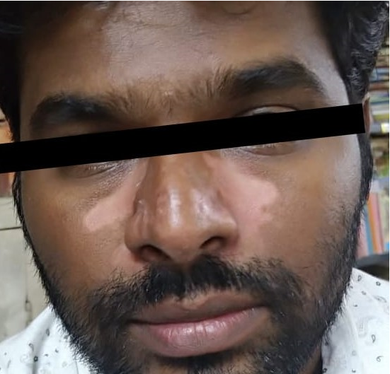+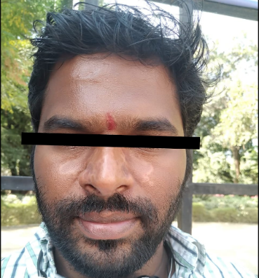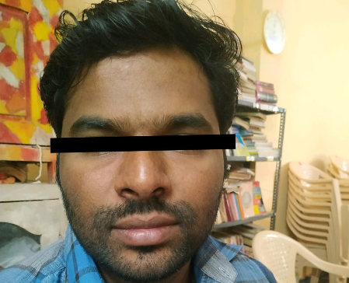
References
1.Jha Niharika, Narayan Vanya. Congenital Vitiligo with positive paternal history-a rare case report. 2020, Vol 1.7, Issue:1, 50-52.
2.Ezzedine K, LimHW, Suzuki T, Katayami I, Hamzavi I, Lan CC, Et al.; Vitiligo Global issue consensus conference panelists. Revised classification/nomenclature of Vitiligo and related issues. The Vitiligo Global Issues consensus conference. Pigment cell Melanoma Res. 2012 May; 25(3); E1-I3
3.Kar P.K Vitiligo: A study of 120 cases. Indian J Dermatol Venereol Leprol 2001; 67: 302-304.

