20 year female

K/C/O

Bartholin cyst since 1 yr

Chief C/O
1)Bartholin cyst(left side of vagina) since 1yr.
-Recurrent swelling after allopathic treatment.
-painful,pain is so severe that can not walk,or sit or sleep properly .
AGG-BEFORE MENSE
AMELI-REST
2)Black spots on back of the shoulder joints since 3 yrs.
-AGG-HEAT
AMELI-COLD
O/E
1)P/A-NAD
2)P/V-SOFT ,PINKISH SWELLING ON LEFT OPENING OF VAGINA EXTEND UPTO LABIA MINORA .
-PAIN ,TENDERNESS ON TOUCH.
Past HO
Malaria

Family HO
Father-DM

Physical Generals
Diet-mix
Appetite-Normal
Desire-sour,EGG
Aversion-sweet.milk
Tongue-pale,clear
Thirst-Thirstlessness,SQLI
Bowel-clear
Bladder-N
Perspiration-profuse from whole body.
Sleep-complete,likes to lying on right side.
Female-
MENSE-Regular,remains for 6 days.pain on lower abdomen.
Mind
Occupation-student
Childhood-good,anger comes easily,obstinate,irritable,good in study.
NOW-
Active,shy nature
Anger comes easily, obstinate mostly at home.
sad fear of separation from her boyfriend.
Emotional about her love affairs.
likes friend circle more than her family .(after staying on hostel)
happy when fulfill her wish.
weeping disposition.
likes consolation.
expressive.
previously very religious ,after not fulfilled her wish she does not like to worship .
gets revengeful thought during anger but vanish after calm down.
Intolerance of lie.
reaction on criticism -angry

Thermal
Towards HOT.
MIASM
Sycotic

Repertorisation Sheet :
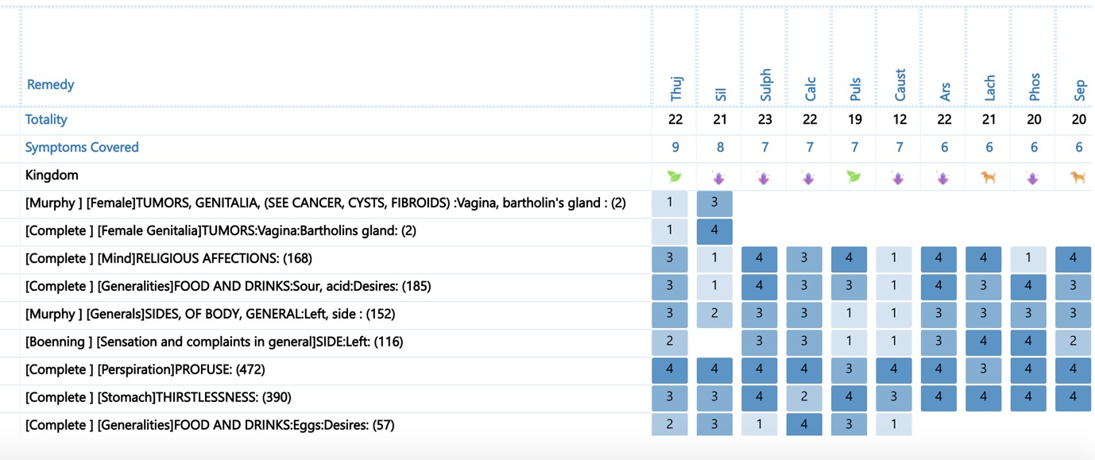

Remedy :

Rx THUJA 30C
TDS FOR 1 MONTH

REASON :it covers the complete totality of the case

Materia Medica -Thuja – Predominately Left sided Remedy ,Sycotic growth
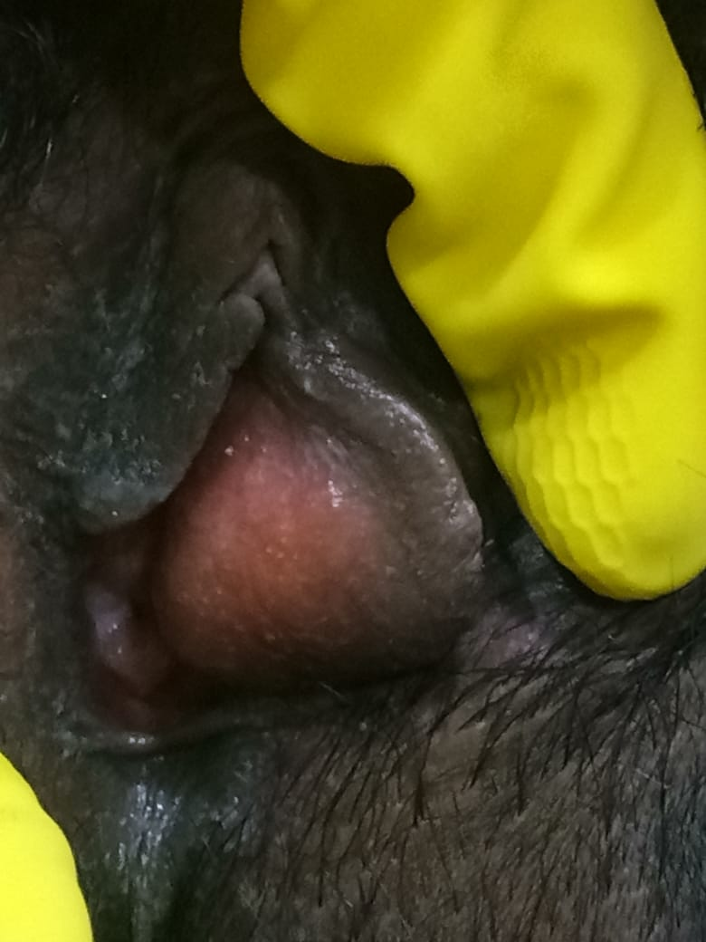
BEFORE TREATMENT

FOLLOW UP : AFTER 1 MONTH
1/08/2018-Much better,improvement. 99 %
NO More Cyst
walking properly.
-black discoloration on back side reduce

AFTER TREATMENT

